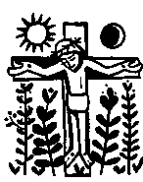

The Passion of our Lord Jesus Christ
according to St Luke

